TUT-12_20103153_Avni_arora_B6

1)

Displays the file content of the text file if it exist and is able to open successfully .

If file gets open then ,

fp>>noskipws>>ch statement in line 18 reads data from file in character-by-character manner, without skipping anywhite spaces.

2)

#include<iostream>

#include<fstream>

#include<stdio.h>

using namespace std;

int main()

{

char fileName[30], ch;

fstream fp;

cout<<"Enter the Name of File: ";

gets(fileName);

fp.open(fileName, fstream::in);

if(!fp)

{

cout<<"\nFile can’t open!";

return 0;

}

**while(!fp.eof())**

**{**

**fp.get(ch);**

**cout<<ch;**

**}**

fp.close();

cout<<endl;

return 0;

}

3)

It reads the data from the “data.txt” file and store in another file “new.txt”

Line by Line.

End of Line in the text is marked by “.”

4)

#include<iostream>

#include <fstream>

#include <string>

using namespace std;

int main()

{

ifstream fin( "data.txt" ) ;

ofstream fout( "new.txt" ) ;

string line ;

**while(getline( fin, line, 100,'.' ))**

**{**

**fout << line<< '\n' ;**

**}**

}

}

5)

#include<iostream>

#include<fstream>

#include<stdio.h>

using namespace std;

int main()

{

char ch;

fstream f1, f2, f3;

f1.open("one.txt", fstream::in);

f2.open("two.txt", fstream::in);

if((!f1) || (!f2))

{

cout<<"\nError in opening files";

return 0;

}

else

{

f3.open("three.txt", fstream::out);

if(!f3)

printf("\nError in opening file");

else

{

while(f1>>noskipws>>ch)

f3<<ch;

f3<<"\n";

while(f2>>noskipws>>ch)

f3<<ch;

cout<<"\nContent of Two File Merged Successfully into Third!";

}

}

f1.close();

f2.close();

f3.close();

cout<<endl;

return 0;

}

Output:

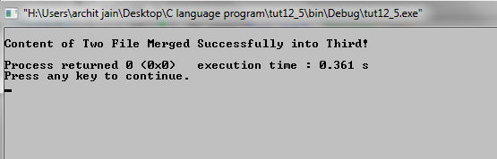

6)

#include <iostream>

#include <fstream>

#include <stdio.h>

#include <stdlib.h>

using namespace std;

int main()

{

char fname[100];

char ch, choice;

fstream f1,f2;

cout << "Enter file name to encrypt: ";

cin >> fname;

f1.open(fname, fstream::in|fstream::out);

f2.open("store.txt", fstream::out);

if(!f1||!f2)

{

cout << "\nError in opening file..!!";

return 0;

}

while(!f1.eof())

{

f1 >> ch;

ch = ch+10;

f2 << ch;

}

f1.close();

f2.close();

f2.open("store.txt", fstream::in);

remove(fname);

f1.open(fname, fstream::out);

if(!f1||!f2)

{

cout << "\nError in opening file..!!";

return 0;

}

while(!f2.eof())

{

f2 >> ch;

f1 << ch;

}

f1.close();

f2.close();

cout << "\nFile " << fname << " enscrypted successfully..!!";

return 0;

}

Output:

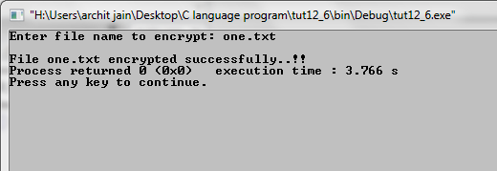

7)

#include <iostream>

#include <fstream>

#include <stdio.h>

#include <stdlib.h>

using namespace std;

int main()

{

char fname[100];

char ch, choice;

fstream f1,f2;

cout << "Enter file name to encrypt: ";

cin >> fname;

f1.open(fname, fstream::in|fstream::out);

f2.open("store.txt", fstream::out);

if(!f1||!f2)

{

cout << "\nError in opening file..!!";

return 0;

}

while(!f1.eof())

{

f1 >> ch;

ch = ch-10;

f2 << ch;

}

f1.close();

f2.close();

f2.open("store.txt", fstream::in);

remove(fname);

f1.open(fname, fstream::out);

if(!f1||!f2)

{

cout << "\nError in opening file..!!";

return 0;

}

while(!f2.eof())

{

f2 >> ch;

f1 << ch;

}

f1.close();

f2.close();

cout << "\nFile " << fname << " descrypted successfully..!!";

return 0;

}

Output:

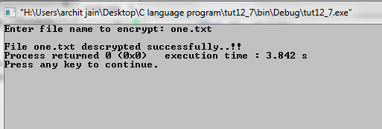

8)

#include <iostream>

#include <fstream>

using namespace std;

int main()

{

fstream fin;

fin.open("file.txt", fstream::in);

if(!fin)

{

cout<<"error in opening file";

return 0;

}

string word;

int count = 0;

cout<<"file content : "<<endl;

while(!fin.eof())

{

fin >> word;

cout<<word<<" ";

count++;

}

cout << "\nNumber of words in the file are: " << count << endl;

fin.close();

return 0;

}

Output:

